Individual Homework Week 2

Using the following ERD, create a diagram using Visual Paradigm. Join the tables and include appropriate cardinality. Choose suitable data types for each attribute. Add a separate entity with your name on it to identify your work. Aside from the entity that is named after you (this has nothing to do with the diagram), make sure that the relations between all four original entities here exhibit referential integrity. Use appropriate cardinality. Make sure the datatypes selected for each attribute are suitable and efficient as well. (I.e. ShopName probably does not need to be 255 characters long. CarID should probably be an integer with around 10 spaces)
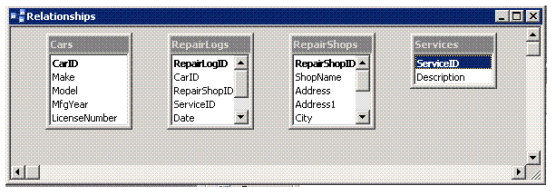

Take a screenshot of your diagram and paste it in MS word. Save this file as a *.doc file so I can open it in Office 2003.

Attach this to your individual folder and label it ERD Homework. This is due Friday January 25 at 6 PM.

